FINAL REPORT

ON
Shortest Distance Using Dijkstra Algorithm

in partial fulfilment for the award of the degree of
BACHELOR OF ENGINEERING
IN
COMPUTER SCIENCE AND ENGINEERING

Submitted by:

Amritansh 24BCS10350
Rachit Yadav 24BCS10335
Prakhar Sisodiya 24BCS10351

Under the Guidance of
Er. Komal Sharma
INSTITUTE – UIE



Chandigarh University
10 November 2025

Index

S. No. | Content | Page No.
1 | Introduction and Literature review | 1-2
2 | Problem definition and objectives | 3-4
3 | Scope | 5
4 | Planning and Task definition | 6-7
5 | System Requiements | 8-9
6 | Output and Analysis | 10
7 | Refrences | 11
8 | Conclusion | 12

Introduction and Literature Review

In the era of digital transformation and intelligent systems, efficient pathfinding has become a cornerstone in navigation systems, logistics management, network routing, and intelligent transportation systems. Whether it’s Google Maps calculating the fastest route, a delivery drone optimizing its trajectory, or a data packet traversing the internet, the underlying principle remains the same — finding the shortest possible path between two points with minimal computational overhead.
Among the numerous algorithms developed for this purpose, Dijkstra’s Algorithm stands out as one of the most fundamental and widely used solutions. Introduced in 1956 by Edsger W. Dijkstra, this algorithm provides a systematic method for determining the minimum distance between a starting node and all other nodes in a weighted graph. Despite being over six decades old, its relevance has only increased, thanks to its adaptability in real-time navigation, artificial intelligence, and geographical information systems (GIS).
The project titled Smart Shortest Path Finder Using Dijkstra’s Algorithm aims to implement this classical algorithm in a modern, interactive, and web-based environment. Built using Python, the system utilizes Streamlit for the front-end interface, NetworkX for graph operations, Geopy for real-world geolocation, and Folium for map visualization. The primary objective is to transform the mathematical concept of Dijkstra’s algorithm into a realistic, visual, and user-driven application that demonstrates how theoretical graph algorithms can solve practical navigation problems.
The motivation behind this project lies in bridging the gap between academic algorithmic learning and real-world geographical systems. Traditional algorithm visualizations are static and abstract. This project brings them to life by letting users add real cities, define roads, and observe real-time shortest paths on a dynamic map interface.
This approach not only improves comprehension but also opens up new possibilities for developing intelligent routing systems, AI-powered logistics platforms, and autonomous navigation frameworks.

Literature Review
- Over the years, several pathfinding algorithms have been proposed, eachoffering unique advantages in terms of speed, complexity, and accuracy. The key studies forming the foundation of this project are summarized below:
- Edsger W. Dijkstra (1956)
Proposed the foundational Shortest Path Algorithm that systematically explores nodes in a graph to find the minimum cost path. Dijkstra’s method uses a greedy approach, continuously selecting the nearest unvisited node until all nodes are reached. It works efficiently for graphs with non-negative edge weights, and forms the basis for modern routing systems.
- Bellman–Ford Algorithm (1958)
Extended Dijkstra’s approach to support negative weights, albeit with higher time complexity of O(V × E). It ensures correctness even in graphs with varying edge conditions.
- Floyd–Warshall Algorithm (1962)
Introduced a matrix-based dynamic programming approach for computing the shortest paths between all pairs of nodes. Although computationally intensive, it’s still used in network topology analysis.
- A (A-star) Search Algorithm (1968)*
Combined Dijkstra’s efficiency with heuristic-driven estimates to minimize search time. It is widely used in AI, robotics, and video game pathfinding, where real-time response is critical.
- Modern GIS and Navigation Research (2000–present):
With the integration of geospatial data, pathfinding has evolved into a hybrid discipline combining graph theory, machine learning, and data visualization.
Studies by Google (2007–2020) and academic researchers have shown that modified Dijkstra’s algorithms, enhanced with heuristics and parallel processing, can handle millions of real-time queries globally.
This cumulative knowledge forms the backbone of the present system — a geographically aware, web-based implementation of Dijkstra’s Algorithm, bridging mathematical precision with visual interactivity.

PROBLEM DEFINITION AND OBJECTIVES
Finding the shortest and most efficient route is an essential requirement across multiple domains — from road navigation and airline scheduling to internet routing and robot path planning. However, most academic implementations of pathfinding algorithms remain theoretical and disconnected from real-world usability.
Existing tools like Google Maps and Apple Maps are proprietary and lack open, customizable frameworks for understanding the internal algorithmic process. Furthermore, they rely on large-scale data processing, making them unsuitable for educational or demonstration purposes.
Hence, there is a need for a lightweight, interactive, and customizable system that:
- Allows users to define their own network of locations and roads.
- Visualizes the graph in real time.
- Computes the shortest path accurately and efficiently.
- Displays results in an intuitive format, including total distance and estimated travel time.
The Smart Dijkstra Path Finder addresses this gap by combining the precision of Dijkstra’s Algorithm with the accessibility of modern web technologies.
Objectives
The project’s main objectives include:
- To implement Dijkstra’s Algorithm for real-world location-based networks.
- To design an interactive web interface that allows users to add cities, connect them via roads, and define distances.
- To integrate Geopy API for automatic geocoding (converting place names into GPS coordinates).
- To visualize the shortest path dynamically using Folium maps embedded in a Streamlit interface.
- To calculate and display distance and time estimates based on average vehicle speed.
- To educate users on the working of Dijkstra’s Algorithm through a graphical, user-friendly representation.
- To ensure scalability, allowing the system to handle multiple nodes and routes efficiently.
- To evaluate performance in terms of execution speed, map rendering, and path accuracy.

Scope
The scope of this project is to develop a Python-based shortest path application that integrates graph theory, geographical mapping, and interactive visualization.
In-Scope Activities
- Implementation of Dijkstra’s algorithm using NetworkX.
- Integration of Geopy for real-world location mapping.
- Use of Folium for dynamic map rendering.
- Interactive GUI development in Streamlit.
- Real-time display of distance and travel time.
- Evaluation of performance and accuracy on multiple datasets.
Out of Scope
- Real-time GPS integration.
- Mobile app deployment.
- Handling of negative-weight edges.
- Large-scale distributed routing simulation.
- 3D or satellite imagery visualization.
The project, however, can be extended in future to include live GPS data, A* pathfinding integration, and multi-route comparison.

Planning and Task definition

To ensure structured development, the project was divided into multiple phases, each with clear objectives, deliverables, and testing checkpoints.4.1 Project Phases and Timeline
Project and Task Definition:
Phase | Duration | Description
Phase 1: Research & Requirement Analysis | Week 1-2 | Study of Dijkstra’s algorithm, understanding libraries (NetworkX, Folium, Streamlit), defining functional requirements.
 | Week 3
  Phase 2: Design
  System architecture design, defining data flow diagrams, and UI layout.
 | Week 4-6
  Phase 3: Implementation
  Core algorithm implementation, integration of map visualization and user interface.
 | Week 7
  Phase 4: Optimization
  Improving algorithm performance, minimizing rendering delays.
 | Week 8
  Phase 5: Testing & Evaluation
  Functional testing, edge-case analysis, and result validation.
 | Week 9 | Report preparation, demonstration, and evaluation.
  Phase 6: Documentation & Presentation
Task Breakdown

Study and document the foundational algorithms – Dijkstra, Bellman-Ford, Floyd–Warshall, and A*.

System Design:

Define modules for data input, computation, and visualization.

Design user interface using Streamlit widgets and layout grids.

Implementation:

Build the graph dynamically using NetworkX.

Use Geopy to fetch latitude and longitude.

Compute shortest path using nx.dijkstra_path() and display results.

Visualize map with Folium markers and colored edges.

Optimization:

Use caching for repeated locations.

Optimize UI rendering to avoid lag on large graphs.

Testing:

Test for connected and disconnected graphs.

Validate against known distances between Indian cities.

Documentation:

Prepare detailed explanation of logic flow, algorithms, and results.

System Requirements

Hardware Requirements
Minimum Configuration:
- Processor: Intel Core i5 (8th Gen or equivalent)
- RAM: 8 GB
- Storage: 10 GB
- Display: 1080p
- Internet: Required for API access
Recommended Configuration:
- Processor: Intel Core i7 / AMD Ryzen 7
- RAM: 16 GB or higher
- Storage: SSD (20 GB+)
- GPU: Optional (for acceleration)

Software Requirements

Operating Systems Supported:
- Windows 10/11
- Ubuntu 20.04+
- macOS (partial support)
Development Tools:
- Python 3.8+
- VS Code / PyCharm IDE
- Git for version control
Libraries:
- NetworkX – for graph modeling
- Streamlit – for UI
- Folium – for maps
- Geopy – for geocoding
- Streamlit-Folium – to embed maps into Streamlit apps

Output and Analysis
- The application allows users to add cities, connect them via roads, and visualize the shortest route interactively.
- The shortest path is highlighted in bright blue, with the start node (green) and end node (red) marked clearly.
- The system displays distance in km and estimated travel time (based on an average speed of 50 km/h).

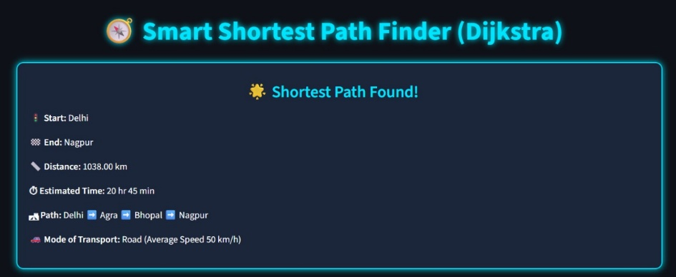

The Folium map shows an interactive route visualization for this output.

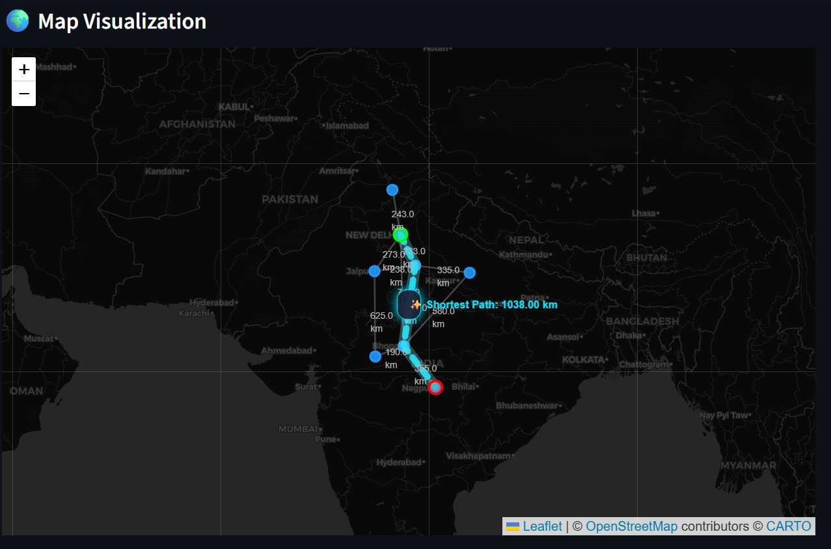

Refrences
NetworkX Documentation, “Network Analysis in Python,” Available: https://networkx.org.
Streamlit Documentation, “Build Data Apps in Python,” Available: https://docs.streamlit.io.
Folium Maps Library, “Interactive Maps with Python,” Available: https://python-visualization.github.io/folium.
Geopy API Documentation, “Geocoding and Reverse Geocoding,” Available: https://geopy.readthedocs.io.
Python Software Foundation, “Python 3.11 Official Documentation,” Available: https://docs.python.org.
W3Schools, “Python Programming Tutorial,” Available: https://www.w3schools.com/python.
Real Python, “NetworkX and Graphs in Python,” Available: https://realpython.com.
GeeksforGeeks, “Dijkstra’s Algorithm for Shortest Paths,” Available: https://www.geeksforgeeks.org/dijkstras-shortest-path-algorithm.
Towards Data Science, “Building Interactive Map Applications with Streamlit and Folium,” Available: https://towardsdatascience.com
Conclusion

The project titled Smart Shortest Path Finder Using Dijkstra’s Algorithm was successfully conceptualized, designed, and implemented with the aim of providing a real-time, interactive visualization of the shortest route between two locations. It bridges the gap between classical computer science algorithms and modern geospatial applications, showing how a foundational graph algorithm can be applied in a highly practical, user-friendly, and educational context.

At its core, the project demonstrates the effectiveness of Dijkstra’s Algorithm, one of the most fundamental yet powerful algorithms in the field of graph theory and network optimization. By integrating it with Python-based tools like NetworkX for graph construction, Streamlit for the interactive front-end, Geopy for geolocation, and Folium for mapping visualization, the system transforms abstract data structures into an intuitive and visually appealing interface.

The main objective of creating an application that allows users to add cities, connect routes, and compute shortest paths dynamically has been achieved successfully. Users can view not only the path sequence but also real-world metrics such as distance (in kilometers) and estimated travel time, making this project relevant to real-world navigation, education, and logistics.

Learning Outcomes

From an educational perspective, this project offered deep insight into multiple domains of computer science:
- Algorithmic Design: Understanding Dijkstra’s step-by-step traversal process and its real-time optimization.
- Data Structures: Application of graphs, priority queues, and hashmaps to store and manipulate data efficiently.
- Software Development Practices: Use of modular programming, state management (Streamlit Session State), and UI integration.
- Geographical Information Systems (GIS): Application of latitude–longitude mapping, coordinate-based route visualization, and spatial data processing.
- Frontend–Backend Integration: Merging algorithmic logic (backend) with interactive visualization (frontend) for seamless user experience.
- Deployment Readiness: Learning how Python-based web apps can serve as lightweight yet powerful tools for technical demonstrations and public use.
The development of this project deepened the understanding of how classical theory meets practical implementation, giving the team hands-on experience in creating an application that is both educational and operationally relevant.

